Source | Orange Labs & Telecom Italia
Title | FSAN - Test plan for GPON Interoperability plugtestsTM hosted by ETSI and CATR
Project | FSAN Interoperability Task Group
Author | Régis Coat & Alessandro Capurso  Orange Labs & Telecom Italia  E-mail: regis.coat@orange-ftgroup.com  E-mail: alessandro.capurso@telecomitalia.it
Contributors
Status: | Version 1
Abstract: | This document informs about specific tests which are recommended for the tests event in the scope of GPON interoperability testing
Tests event n°8

GPON tests definition document
Version V1 date: 08/11/2026

SUMMARY

Introduction 4
1 Participants 5
2 Mandatory/Optional test cases 6
3 Test Environment Overview 7
Facility Description 7
Test Position Description 8
Test Equipment and Components 8
Testing Aspects 9
4 Test Cases 10
4.1 Preliminary test case – Provisioning using serial number method 11
4.2 VLAN architectures: N:1 model in bridge configuration described in BBF TR-156 12
4.2.1 Architecture n°1 – pbit mapping (pbit only) 12
4.2.2 Architecture n°2 – pbit mapping (pbit only) 15
4.2.3 Architecture n°3 – VID mapping (VID only) Scheduler between GEM port and T-CONT 18
4.2.4 Architecture n°4 – pbit mapping (pbit only) 21
4.3 VLAN architectures: 1:1 model described in BBF TR-156 27
4.3.1 Architecture n°1 – VID mapping (VID only) 27
4.4 VLAN architecture: VBES mode 33
4.4.1 Architecture n°1: VBES architecture with p_bit mapping (pbit only) 33
5 Blindfold pairing 36
6 Provisioning using Registration ID method 37
7 Tests Schedule 39
8 Expected result metrics 40
Annexes 41
Annex 1: Template for test cases 41

Revision History

Draft | Date | Description
0.1 | 10/02 | Initial draft
0.3 | 11/03 | removed optional test cases
1 | 11/06 | Final version (updated test enviroment)

Introduction

This document is meant to fully describe the plugtest TM test plan (including test cases to be used), the test sequence and the enabling test devices and tools available.

Each vendor attending the plugtest TM should be able to use the information contained in this document to evaluate, and if necessary develop, the capability of its solution to match the intended interoperability assessment tests. This document is also intended to specify the materials and equipment that the participants should bring to the test event.

All feedback is welcome to consolidate the tests proposed.

This plugtest TM is dedicated to verify that the ITU-T OMCI Implementers' guide version 1 and Broadband Forum TR-156 allow "plug and play" GPON interoperability.
An official pairing is declared as successful only if developments are 100% compliant with these two documents.

Mike Shaffer who is the OISG coordinator will be present during the week. He will act as a referee. If vendors do not agree on a common OMCI model, he will analyze the situation and solve it by saying which OMCI model is the right one or if there is something missing in the OMCI Implementers' guide, he will take the action point to solve the issue.

Participants are requested to be in the test event rooms all the week.

Participants

 | Vendors | OLT | ONT
1 | Alcatel-Lucent | X | X
2 | Broadcom |  | X
3 | Broadlight |  | X
4 | Cambridge |  | X
5 | Comtrend |  | X
6 | Cortina Systems |  | X
7 | Ericsson | X | X
8 | Huawei | X | X
9 | Motorola | X
10 | PMC Sierra |  | X
11 | RAD |  | X
12 | TECOM |  | X
13 | Transwitch |  | X
14 | ZTE | X | X
 | Observers
15 | TECNALIA | GPON analyzer
16 | Mike Shaffer | OISG

Mandatory/Optional test cases

Test  case n° | Test case | Mandatory | Optional
0 | Provisioning using serial number | X
1 | N:1 Architecture n°1 | X
2 | N:1 Architecture n°2 | X
3 | N:1 Architecture n°3 | X
4.1 | N:1 Architecture n°4.1 | X
4.2 | N:1 Architecture n°4.2 | X
5.1 | 1:1 Architecture n°1_1 | X or test 5.2
5.2 | 1:1 Architecture n°1_2 | X or tests 5.1
6 | VBES Architecture n°1 | X
7 | Provisioning using Registration ID method | X

Test Environment Overview
This section highlights the test environment being provided for the Test Event, including the facilities, test positions, test equipment, and any required ancillary support equipment.

Facility Description
A sample layout of the test space is provided below.

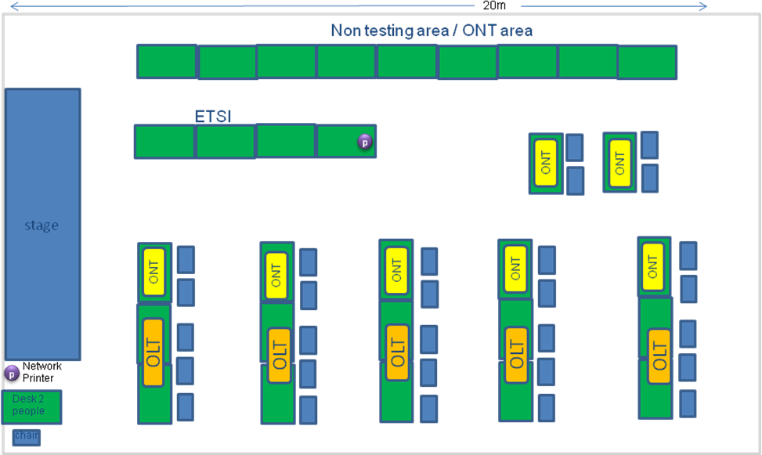

Figure 1: Sample Test Position Layout

The test space consists of up to 5 “OLT test work positions” (composed of three tables). The ETSI position is reserved for event manager and observers.

Electrical Service: Electrical service in the form of 220 Vac, 50 Hz (16 amp max) service will be provided to each test positions. Two five outlet power strip (Type I socket) will be provided per test position. Vendors are advised to bring additional power strips if needed. Vendors requiring other power sources (including DC) have to bring the appropriate equipment. Please note that all Vendors should bring as many Type I socket adaptor as they require. These will not be provided.

Data Communications/Internet: 802.11 wireless (VPN capable) Internet access will be provided.

In addition to the facilities described above, the following will be available:
- Network Printer
- Photocopy and fax
- PC with video projector for Test Pairing tracking and Test Results collecting via an electronic “drop-box”.
- Full service cafeteria

Test Position Description
Each test position consists of three tables:
- one for the OLT vendor
- one for the ONT vendor involved in the active session
- one for equipments

Each test position will be equipped by the host as follows:

Power: 220VAC/50 Hz, through Type I sockets

OLT/ONT Test Position:

- Provided by organizer:
  - 1 x 1by4 splitter
  - single mode fibers
    - 2 x SC/APC – SC/APC
    - 1 x SC/PC – SC/APC
    - 1 x dual fiber LC/PC –SC/PC
    - 1 x dual fiber SC/PC – SC/PC
    - 1 x dual fiber LC/PC – LC/PC
  - 3 x adapters SC/APC
  - 1 x fixed 5dB attenuator (SC-APC)
  - 1 x fixed 10dB attenuator (SC-APC)
  - 2 x RJ45 Ethernet cable (3 m)
  - 1 x 5 ports HUB

- In charge of each vendor:
  - Electrical adaptors to type I sockets and power 48V converters

Test Equipment and Components
OLT vendors are requested to provide, at a minimum, their own Ethernet data generator/traffic analyzer. This is intended to eliminate “bottlenecks” caused by the sharing of common test equipment/test equipment operators. OLT vendors are expected to be familiar with the operation of any test equipment they provide, including having test equipment scripts pre-defined to allow the efficient execution of any mandatory test cases specified in this document. The Ethernet tester has to be able to fit the entire test plan.

Testing Aspects
Participants providing both OLT and ONT equipment to the Test Event are expected to provide adequate engineering support to allow both equipment types to be concurrently engaged in testing (at least, one specific engineer per equipment and a maximum of 2).

All test platforms must support OMCI-based provisioning. ONT platforms that require configuration through locally issued commands or scripting (as a substitute for processing OMCI-based commands) are NOT eligible for this event.
It is assumed GTC layer functionality of test platforms are stable and mature.

Test Cases

The content of this test plan will be focused on services architectures implementation.

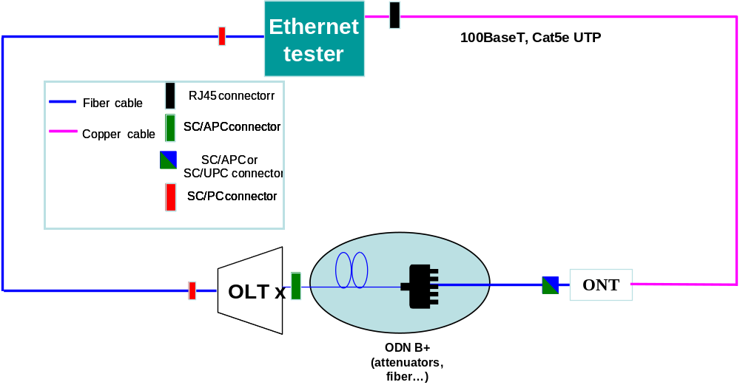
Figure 2: Tests infrastructure

* All configurations will be realized using PLOAM/OMCI standardized messages.
* All configurations must be 100% compliant with the ITU-T OMCI Implementers' guide.
* No local actions on the ONT are allowed (except for Registration ID provisioning method).
* VLAN manipulations including Ethertype modifications location must be compliant with the description given in TR-156 (for example, VLAN manipulations at the ONT and not at the OLT for N:1 VLAN architecture)

*All ONT vendors should have the same serial number ETSI00000001

Some of the test cases described below include GEM frames scheduler but this aspect won't be tested during the test event.
For this event, we will only consider one queue per TCONT.

Regarding filtering rules, this is not part of the current event!

Preliminary test case – Provisioning using serial number method

GATE: 30 minutes
This first test case must be handled in a maximum of 30 minutes.
If this gate is reached with an ONT which is not ranged, one of the vendors involved in the active pairing has the capability to stop the session. In this case, the involved OLT will restart a session with another ONT. The ONT will be chosen by the lab manager in a specific waiting list.
With the agreement of both sides, the pairing could also continue.

Test Case n°0

Test Setup
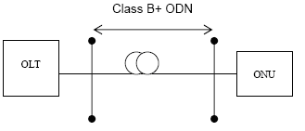

Purpose: To verify that the OLT can initialize the ONU using the serial number method. (Same serial number for all ONT vendors ETSI00000001)

Standard: Section 10 of G.984.3

Preconditions: 1 ONU not connected to the PON and powered down. At the OLT, the serial number of the ONU is configured.

Test Equipment: None

Test Procedure
1. Connect the ONU to the fiber and Power Up it
2. The ONU shall range after the fiber connection

Pass-fail criteria: Fail if the ONU does not range

Test report: Pass _____ Fail _____ Not Supported _____

Observation:

Last Modified:

VLAN architectures: N:1 model in bridge configuration described in BBF TR-156
For all N:1 architecture VLAN manipulation is always done at the ONU (see BBF TR-156 section 5.1.1)

Architecture n°1 – pbit mapping (pbit only)
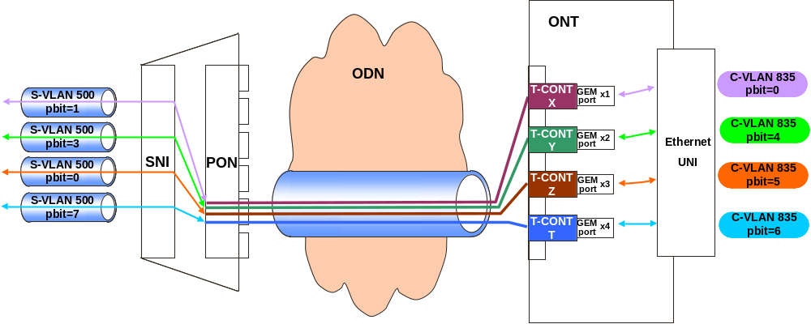
Figure 3: Single VID with different pbit values (VID and pbit translation)

Test Case n°1

Test Setup: Shown in Figure 3

Purpose:
This test verifies the GPON system capability to deliver a VLAN architecture based on the following description:
- 1 VLAN level on the aggregation network side and on the access network side
- Each flow on the customer network side is 802.1q tagged
- Translation of the VID value: C_VID must be translated to S_VID in the upstream direction and S_VID to C_VID in the downstream direction
- Translation of the p_bit value: C_p_bit must be translated to S_p_bit in the upstream direction and S_p_bit to C_p_bit in the downstream direction.
- 1 pbit value per GEM port
- 1 GEM port per TCONT
- Each TCONT is associated to one specific p_bit value
At the ONT only one UNI interface is used

Standard: Section 5.1.1 of TR-156 and ITU-T G984.4 Implementers' Guide

Preconditions:
All provisioning and management process between OLT and ONT must be fully compliant with ITU-T G984.4 OMCI Implementers' Guide version 1

Test Equipment: Ethernet tester

Test Procedure
Simultaneous transmission with all p_bit (0, 4, 5, 6)
Use OMCI commands to setup the entire configuration from the OLT to the ONT described in Figure 3
- Create a connection between the OLT and ONT with a C_VID identifier (VID=xx) and C_p_bit identifier (p_bit=n) and a S_VID identifier (VID=yy) and S_p_bit identifier (p_bit=m).

Step 1: Define and send following frames (upstream direction)
 | Dst Mac Address | Scr Mac Address | C-VID | C_p_bit | Data
Frame 1 | 00-00-00-00-11 | 00-00-00-00-01 | 835 | 0 | XXXXXX
Frame 2 | 00-00-00-00-12 | 00-00-00-00-02 | 835 | 4 | XXXXXX
Frame 3 | 00-00-00-00-13 | 00-00-00-00-03 | 835 | 5 | XXXXXX
Frame 4 | 00-00-00-00-14 | 00-00-00-00-04 | 835 | 6 | XXXXXX
Verify that frames below are received on SNI port with the S-VID = 500, and S_p_bit ≠ C_p_bit.
 | Dst Mac Address | Scr Mac Address | S-VID | S_p_bit | Data
Frame 1 | 00-00-00-00-11 | 00-00-00-00-01 | 500 | 1 | XXXXXX
Frame 2 | 00-00-00-00-12 | 00-00-00-00-02 | 500 | 3 | XXXXXX
Frame 3 | 00-00-00-00-13 | 00-00-00-00-03 | 500 | 0 | XXXXXX
Frame 4 | 00-00-00-00-14 | 00-00-00-00-04 | 500 | 7 | XXXXXX

Step 2: Define and send following frames (downstream direction)
 | Dst Mac Address | Scr Mac Address | S-VID | S_p_bit | Data
Frame 1 | 00-00-00-00-01 | 00-00-00-00-11 | 500 | 1 | XXXXXX
Frame 2 | 00-00-00-00-02 | 00-00-00-00-12 | 500 | 3 | XXXXXX
Frame 3 | 00-00-00-00-03 | 00-00-00-00-13 | 500 | 0 | XXXXXX
Frame 4 | 00-00-00-00-04 | 00-00-00-00-14 | 500 | 7 | XXXXXX
Verify that frames below are received on uNI port with the C-VID = 835, and C_p_bit ≠ S_p_bit.
 | Dst Mac Address | Scr Mac Address | C-VID | C_p_bit | Data
Frame 1 | 00-00-00-00-01 | 00-00-00-00-11 | 835 | 0 | XXXXXX
Frame 2 | 00-00-00-00-02 | 00-00-00-00-12 | 835 | 4 | XXXXXX
Frame 3 | 00-00-00-00-03 | 00-00-00-00-13 | 835 | 5 | XXXXXX
Frame 4 | 00-00-00-00-04 | 00-00-00-00-14 | 835 | 6 | XXXXXX

Verify if these flows use the correct GEM ports / TCONTs

Pass-fail criteria:
Pass if flows correctly forwarded on the GPON system. Correctly means "as described in section "Test Procedure""

Test report: Pass _____ Fail _____ Not Supported _____

Observation:

Last Modified:

Architecture n°2 – pbit mapping (pbit only)
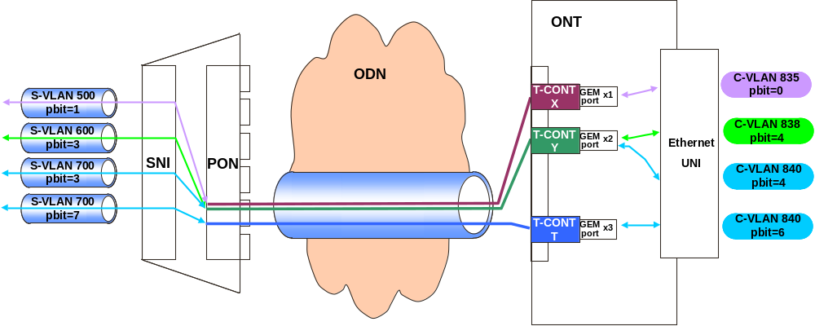
Figure 4: Different VID with different pbit (VID and pbit translation)

Test Case n°2

Test Setup: Shown in Figure 4

Purpose:
This test verifies the GPON system capability to deliver a VLAN architecture based on the following description:
- 1 VLAN level on the aggregation network side and on the access network side
- Each flow on the customer network side is 802.1q tagged
- Translation of the VID value: C_VID must be translated to S_VID in the upstream direction and S_VID to C_VID in the downstream direction
- Translation of the p_bit value: C_p_bit must be translated to S_p_bit in the upstream direction and S_p_bit to C_p_bit in the downstream direction.
- 1 pbit value per GEM port
- C-VLAN 838 and C_VLAN 840 use the same GEMport x2
- 1 GEM port per TCONT
- Each TCONT is associated to one specific p_bit value
At the ONT only one UNI interface is used

Standard: Section 5.1.1 of TR-156 and ITU-T G984.4 Implementers' Guide

Preconditions:
All provisioning and management process between OLT and ONT must be fully compliant with ITU-T G984.4 OMCI Implementers' Guide version 1

Test Equipment: Ethernet tester

Test Procedure
Simultaneous transmission with all VLAN (835, 838, 840)
Use OMCI commands to setup the entire configuration from the OLT to the ONT described in Figure 4
- Create a connection between the OLT and ONT with a C_VID identifier (VID=xx) and C_p_bit identifier (p_bit=n) and a S_VID identifier (VID=yy) and S_p_bit identifier (p_bit=m).

Step 1: Define and send following frames (upstream direction)
 | Dst Mac Address | Scr Mac Address | C-VID | C_p_bit | Data
Frame 1 | 00-00-00-00-11 | 00-00-00-00-01 | 835 | 0 | XXXXXX
Frame 2 | 00-00-00-00-12 | 00-00-00-00-02 | 838 | 4 | XXXXXX
Frame 3 | 00-00-00-00-13 | 00-00-00-00-03 | 840 | 4 | XXXXXX
Frame 4 | 00-00-00-00-14 | 00-00-00-00-04 | 840 | 6 | XXXXXX
Verify that frames below are received on SNI port with the S-VID ≠ C-VID, and S_p_bit ≠ C_p_bit.
 | Dst Mac Address | Scr Mac Address | S-VID | S_p_bit | Data
Frame 1 | 00-00-00-00-11 | 00-00-00-00-01 | 500 | 1 | XXXXXX
Frame 2 | 00-00-00-00-12 | 00-00-00-00-02 | 600 | 3 | XXXXXX
Frame 3 | 00-00-00-00-13 | 00-00-00-00-03 | 700 | 3 | XXXXXX
Frame 4 | 00-00-00-00-14 | 00-00-00-00-04 | 700 | 7 | XXXXXX

Step 2: Define and send following frames (downstream direction)
 | Dst Mac Address | Scr Mac Address | S-VID | S_p_bit | Data
Frame 1 | 00-00-00-00-01 | 00-00-00-00-11 | 500 | 1 | XXXXXX
Frame 2 | 00-00-00-00-02 | 00-00-00-00-12 | 600 | 3 | XXXXXX
Frame 3 | 00-00-00-00-03 | 00-00-00-00-13 | 700 | 3 | XXXXXX
Frame 4 | 00-00-00-00-04 | 00-00-00-00-14 | 700 | 7 | XXXXXX
Verify that frames below are received on UNI port with the C-VID ≠ S-VID, and C_p_bit ≠ S_p_bit.
 | Dst Mac Address | Scr Mac Address | C-VID | C_p_bit | Data
Frame 1 | 00-00-00-00-01 | 00-00-00-00-11 | 835 | 0 | XXXXXX
Frame 2 | 00-00-00-00-02 | 00-00-00-00-12 | 838 | 4 | XXXXXX
Frame 3 | 00-00-00-00-03 | 00-00-00-00-13 | 840 | 4 | XXXXXX
Frame 4 | 00-00-00-00-04 | 00-00-00-00-14 | 840 | 6 | XXXXXX

Verify if these flows use the correct GEM ports / TCONTs

Pass-fail criteria:
Pass if flows correctly forwarded on the GPON system. Correctly means "as described in section "Test Procedure""

Test report: Pass _____ Fail _____ Not Supported _____

Observation:

Last Modified:

Architecture n°3 – VID mapping (VID only) Scheduler between GEM port and T-CONT

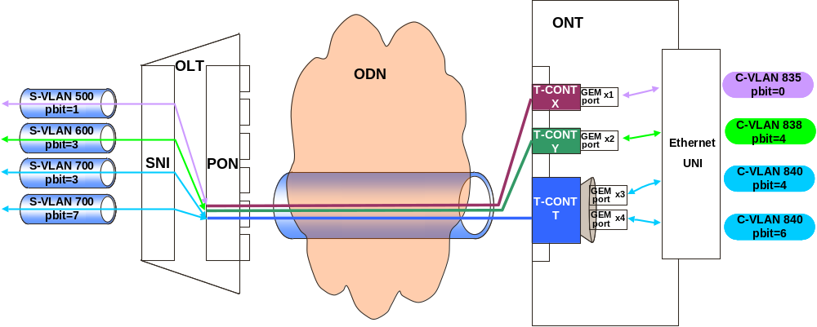
Figure 5: Different VID with different pbit (VID and pbit translation)

The GEM frames scheduler represented on the figure in the ONT is just mentioned as information and won't be tested during the event!
Test Case n°3

Test Setup: Shown in Figure 5

Purpose:
This test verifies the GPON system capability to deliver a VLAN architecture based on the following description:
- 1 VLAN level on the aggregation network side and on the access network side
- Each flow on the customer network side is 802.1q tagged
- Translation of the VID value: C_VID must be translated to S_VID in the upstream direction and S_VID to C_VID in the downstream direction
- Translation of the p_bit value: C_p_bit must be translated to S_p_bit in the upstream direction and S_p_bit to C_p_bit in the downstream direction.
- 1 VLAN value per GEM port
- 1 p_bit value per GEMport
- 1 or 2 GEM port per TCONT
- Each TCONT can be associated to multiple p_bit values (scheduler)
At the ONT only one UNI interface is used

Standard: Section 5.1.1 of TR-156 and ITU-T G984.4 Implementers' Guide

Preconditions:
All provisioning and management process between OLT and ONT must be fully compliant with ITU-T G984.4 OMCI Implementers' Guide version 1

Test Equipment: Ethernet tester

Test Procedure
Simultaneous transmission with all VLAN (835, 838, 840)
Use OMCI commands to setup the entire configuration from the OLT to the ONT described in Figure 5
- Create a connection between the OLT and ONT with a C_VID identifier (VID=xx) and C_p_bit identifier (p_bit=n) and a S_VID identifier (VID=yy) and S_p_bit identifier (p_bit=m).

Step 1: Define and send following frames (upstream direction)
 | Dst Mac Address | Scr Mac Address | C-VID | C_p_bit | Data
Frame 1 | 00-00-00-00-11 | 00-00-00-00-01 | 835 | 0 | XXXXXX
Frame 2 | 00-00-00-00-12 | 00-00-00-00-02 | 838 | 4 | XXXXXX
Frame 3 | 00-00-00-00-13 | 00-00-00-00-03 | 840 | 4 | XXXXXX
Frame 4 | 00-00-00-00-14 | 00-00-00-00-04 | 840 | 6 | XXXXXX
Verify that frames below are received on SNI port with the S-VID ≠ C-VID, and S_p_bit ≠ C_p_bit.
 | Dst Mac Address | Scr Mac Address | S-VID | S_p_bit | Data
Frame 1 | 00-00-00-00-11 | 00-00-00-00-01 | 500 | 1 | XXXXXX
Frame 2 | 00-00-00-00-12 | 00-00-00-00-02 | 600 | 3 | XXXXXX
Frame 3 | 00-00-00-00-13 | 00-00-00-00-03 | 700 | 3 | XXXXXX
Frame 4 | 00-00-00-00-14 | 00-00-00-00-04 | 700 | 7 | XXXXXX

Step 2: Define and send following frames (downstream direction)
 | Dst Mac Address | Scr Mac Address | S-VID | S_p_bit | Data
Frame 1 | 00-00-00-00-01 | 00-00-00-00-11 | 500 | 1 | XXXXXX
Frame 2 | 00-00-00-00-02 | 00-00-00-00-12 | 600 | 3 | XXXXXX
Frame 3 | 00-00-00-00-03 | 00-00-00-00-13 | 700 | 3 | XXXXXX
Frame 4 | 00-00-00-00-04 | 00-00-00-00-14 | 700 | 7 | XXXXXX
Verify that frames below are received on UNI port with the C-VID ≠ S-VID, and C_p_bit ≠ S_p_bit.
 | Dst Mac Address | Scr Mac Address | C-VID | C_p_bit | Data
Frame 1 | 00-00-00-00-01 | 00-00-00-00-11 | 835 | 0 | XXXXXX
Frame 2 | 00-00-00-00-02 | 00-00-00-00-12 | 838 | 4 | XXXXXX
Frame 3 | 00-00-00-00-03 | 00-00-00-00-13 | 840 | 4 | XXXXXX
Frame 4 | 00-00-00-00-04 | 00-00-00-00-14 | 840 | 6 | XXXXXX

Verify if these flows use the correct GEM ports / TCONTs

Pass-fail criteria:
Pass if flows correctly forwarded on the GPON system. Correctly means "as described in section "Test Procedure""

Test report: Pass _____ Fail _____ Not Supported _____

Observation:

Last Modified:

Architecture n°4 – pbit mapping (pbit only)

Scheduler between UNI and GEMport
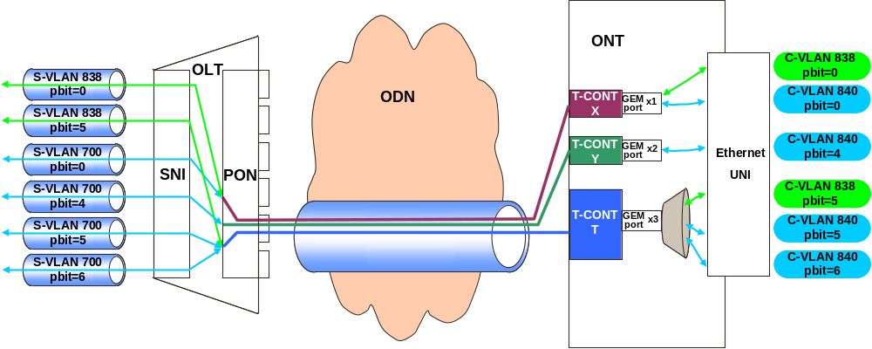
Figure 6: Different VID with different pbit (VID and pbit translation)

The Ethernet scheduler represented on the figure in the ONT is just mentioned as information and won't be tested during the event!
Test Case n°4.1

Test Setup: Shown in Figure 6

Purpose:
This test verifies the GPON system capability to deliver a VLAN architecture based on the following description:
- 1 VLAN level on the aggregation network side and on the access network side
- Each flow on the customer network side is 802.1q tagged
- Translation of the VID value: C_VID must be translated to S_VID in the upstream direction and S_VID to C_VID in the downstream direction (for C-VID 840)
- No VID translation for C-VID 838
- No p_bit translation
- 1 or more p_bit value per GEM port
- 1 GEM port per TCONT
- Each TCONT can be associated to multiple p_bit values (scheduler)
At the ONT only one UNI interface is used

Standard: Section 5.1.1 of TR-156 and ITU-T G984.4 Implementers' Guide

Preconditions:
All provisioning and management process between OLT and ONT must be fully compliant with ITU-T G984.4 OMCI Implementers' Guide version 1

Test Equipment: Ethernet tester

Test Procedure
Simultaneous transmission with all VLAN (838, 840)
Use OMCI commands to setup the entire configuration from the OLT to the ONT described in Figure 6
- Create a connection between the OLT and ONT with a C_VID identifier (VID=xx) and C_p_bit identifier (p_bit=n) and a S_VID identifier (VID=yy) and S_p_bit identifier (p_bit=m).

Step 1: Define and send following frames (upstream direction)
 | Dst Mac Address | Scr Mac Address | C-VID | C_p_bit | Data
Frame 1 | 00-00-00-00-11 | 00-00-00-00-01 | 838 | 0 | XXXXXX
Frame 2 | 00-00-00-00-12 | 00-00-00-00-02 | 838 | 5 | XXXXXX
Frame 3 | 00-00-00-00-13 | 00-00-00-00-03 | 840 | 0 | XXXXXX
Frame 4 | 00-00-00-00-14 | 00-00-00-00-04 | 840 | 4 | XXXXXX
Frame 5 | 00-00-00-00-15 | 00-00-00-00-05 | 840 | 5 | XXXXXX
Frame 6 | 00-00-00-00-16 | 00-00-00-00-06 | 840 | 6 | XXXXXX
Verify that frames below are received on SNI port
 | Dst Mac Address | Scr Mac Address | S-VID | S_p_bit | Data
Frame 1 | 00-00-00-00-11 | 00-00-00-00-01 | 838 | 0 | XXXXXX
Frame 2 | 00-00-00-00-12 | 00-00-00-00-02 | 838 | 5 | XXXXXX
Frame 3 | 00-00-00-00-13 | 00-00-00-00-03 | 700 | 0 | XXXXXX
Frame 4 | 00-00-00-00-14 | 00-00-00-00-04 | 700 | 4 | XXXXXX
Frame 5 | 00-00-00-00-15 | 00-00-00-00-05 | 700 | 5 | XXXXXX
Frame 6 | 00-00-00-00-16 | 00-00-00-00-06 | 700 | 6 | XXXXXX

Step 2: Define and send following frames (downstream direction)
 | Dst Mac Address | Scr Mac Address | S-VID | S_p_bit | Data
Frame 1 | 00-00-00-00-01 | 00-00-00-00-11 | 838 | 0 | XXXXXX
Frame 2 | 00-00-00-00-02 | 00-00-00-00-12 | 838 | 5 | XXXXXX
Frame 3 | 00-00-00-00-03 | 00-00-00-00-13 | 700 | 0 | XXXXXX
Frame 4 | 00-00-00-00-04 | 00-00-00-00-14 | 700 | 4 | XXXXXX
Frame 5 | 00-00-00-00-05 | 00-00-00-00-15 | 700 | 5 | XXXXXX
Frame 6 | 00-00-00-00-06 | 00-00-00-00-16 | 700 | 6 | XXXXXX
Verify that frames below are received on UNI port
 | Dst Mac Address | Scr Mac Address | C-VID | C_p_bit | Data
Frame 1 | 00-00-00-00-01 | 00-00-00-00-11 | 838 | 0 | XXXXXX
Frame 2 | 00-00-00-00-02 | 00-00-00-00-12 | 838 | 5 | XXXXXX
Frame 3 | 00-00-00-00-03 | 00-00-00-00-13 | 840 | 0 | XXXXXX
Frame 4 | 00-00-00-00-04 | 00-00-00-00-14 | 840 | 4 | XXXXXX
Frame 5 | 00-00-00-00-05 | 00-00-00-00-15 | 840 | 5 | XXXXXX
Frame 6 | 00-00-00-00-06 | 00-00-00-00-16 | 840 | 6 | XXXXXX

Verify if these flows use the correct GEM ports / TCONTs

Pass-fail criteria:
Pass if flows correctly forwarded on the GPON system. Correctly means "as described in section "Test Procedure""

Test report: Pass _____ Fail _____ Not Supported _____

Observation:

Last Modified:

Scheduler between GEMport and T-CONT
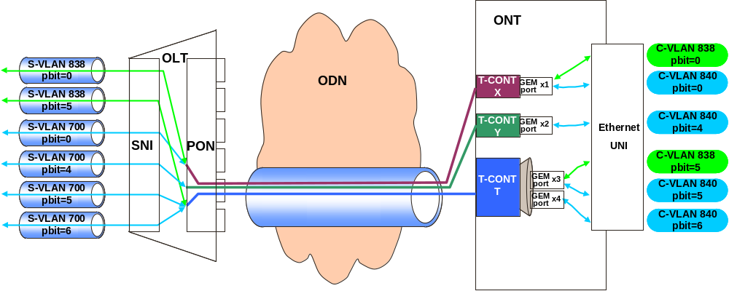
Figure 7: Different VID with different pbit (VID and pbit translation)

The GEM frames scheduler represented on the figure in the ONT is just mentioned as information and won't be tested during the event!
Test Case n°4.2

Test Setup: Shown in Figure 7

Purpose:
This test verifies the GPON system capability to deliver a VLAN architecture based on the following description:
- 1 VLAN level on the aggregation network side and on the access network side
- Each flow on the customer network side is 802.1q tagged
- Translation of the VID value: C_VID must be translated to S_VID in the upstream direction and S_VID to C_VID in the downstream direction (for C-VID 840)
- No VID translation for C-VID 838
- No p_bit translation
- 1 p_bit value per GEM port
- 1 or more GEM port per TCONT
- Each TCONT can be associated to multiple p_bit values (scheduler)
At the ONT only one UNI interface is used

Standard: Section 5.1.1 of TR-156 and ITU-T G984.4 Implementers' Guide

Preconditions:
All provisioning and management process between OLT and ONT must be fully compliant with ITU-T G984.4 OMCI Implementers' Guide version 1

Test Equipment: Ethernet tester

Test Procedure
Simultaneous transmission with all VLAN (838, 840)
Use OMCI commands to setup the entire configuration from the OLT to the ONT described in Figure 7
- Create a connection between the OLT and ONT with a C_VID identifier (VID=xx) and C_p_bit identifier (p_bit=n) and a S_VID identifier (VID=yy) and S_p_bit identifier (p_bit=m).

Step 1: Define and send following frames (upstream direction)
 | Dst Mac Address | Scr Mac Address | C-VID | C_p_bit | Data
Frame 1 | 00-00-00-00-11 | 00-00-00-00-01 | 838 | 0 | XXXXXX
Frame 2 | 00-00-00-00-12 | 00-00-00-00-02 | 838 | 5 | XXXXXX
Frame 3 | 00-00-00-00-13 | 00-00-00-00-03 | 840 | 0 | XXXXXX
Frame 4 | 00-00-00-00-14 | 00-00-00-00-04 | 840 | 4 | XXXXXX
Frame 5 | 00-00-00-00-15 | 00-00-00-00-05 | 840 | 5 | XXXXXX
Frame 6 | 00-00-00-00-16 | 00-00-00-00-06 | 840 | 6 | XXXXXX
Verify that frames below are received on SNI port
 | Dst Mac Address | Scr Mac Address | S-VID | S_p_bit | Data
Frame 1 | 00-00-00-00-11 | 00-00-00-00-01 | 838 | 0 | XXXXXX
Frame 2 | 00-00-00-00-12 | 00-00-00-00-02 | 838 | 5 | XXXXXX
Frame 3 | 00-00-00-00-13 | 00-00-00-00-03 | 700 | 0 | XXXXXX
Frame 4 | 00-00-00-00-14 | 00-00-00-00-04 | 700 | 4 | XXXXXX
Frame 5 | 00-00-00-00-15 | 00-00-00-00-05 | 700 | 5 | XXXXXX
Frame 6 | 00-00-00-00-16 | 00-00-00-00-06 | 700 | 6 | XXXXXX

Step 2: Define and send following frames (downstream direction)
 | Dst Mac Address | Scr Mac Address | S-VID | S_p_bit | Data
Frame 1 | 00-00-00-00-01 | 00-00-00-00-11 | 838 | 0 | XXXXXX
Frame 2 | 00-00-00-00-02 | 00-00-00-00-12 | 838 | 5 | XXXXXX
Frame 3 | 00-00-00-00-03 | 00-00-00-00-13 | 700 | 0 | XXXXXX
Frame 4 | 00-00-00-00-04 | 00-00-00-00-14 | 700 | 4 | XXXXXX
Frame 5 | 00-00-00-00-05 | 00-00-00-00-15 | 700 | 5 | XXXXXX
Frame 6 | 00-00-00-00-06 | 00-00-00-00-16 | 700 | 6 | XXXXXX
Verify that frames below are received on UNI port
 | Dst Mac Address | Scr Mac Address | C-VID | C_p_bit | Data
Frame 1 | 00-00-00-00-01 | 00-00-00-00-11 | 838 | 0 | XXXXXX
Frame 2 | 00-00-00-00-02 | 00-00-00-00-12 | 838 | 5 | XXXXXX
Frame 3 | 00-00-00-00-03 | 00-00-00-00-13 | 840 | 0 | XXXXXX
Frame 4 | 00-00-00-00-04 | 00-00-00-00-14 | 840 | 4 | XXXXXX
Frame 5 | 00-00-00-00-05 | 00-00-00-00-15 | 840 | 5 | XXXXXX
Frame 6 | 00-00-00-00-06 | 00-00-00-00-16 | 840 | 6 | XXXXXX

Verify if these flows use the correct GEM ports / TCONTs

Pass-fail criteria:
Pass if flows correctly forwarded on the GPON system. Correctly means "as described in section "Test Procedure""

Test report: Pass _____ Fail _____ Not Supported _____

Observation:

Last Modified:

VLAN architectures: 1:1 model described in BBF TR-156

Architecture n°1 – VID mapping (VID only)

Architecture for ONT with multiple UNI
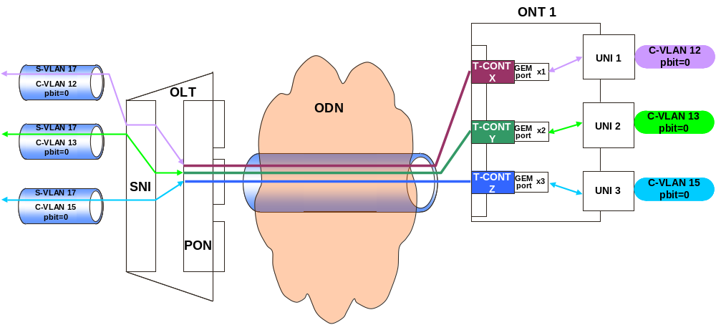
Figure 8: Different VID with same pbit (dual tagged, multiple UNI)
Test Case n°5.1

Test Setup: Shown in Figure 8.

Purpose:
This test verifies the GPON system capability to deliver a VLAN architecture based on the following description:
- 2 VLAN levels on the aggregation network side and 1 VLAN level on the access network side
- Each flow on the customer network side is 802.1q tagged
- Replication of the C_VID value
- Replication of the pbit value
- Unique S_VID per PON port
- 1 C_VID value per GEM port
- 1 pbit value per GEM port
- 1 GEM port per TCONT

At the ONT several UNI interfaces are used

Standard: Section 5.1.1 of TR-156 and ITU-T G984.4 Implementers' Guide

Preconditions:
OLT must be in bridge mode
All provisioning and management process between OLT and ONT must be fully compliant with ITU-T G984.4 OMCI Implementers' Guide version 1

Test Equipment: Ethernet tester

Test Procedure
Simultaneous transmission with all VLAN (12, 13, 15)
Use OMCI commands to setup the entire configuration from the OLT to the ONT described in Figure 8
- Create an Connection between the OLT and ONT with a C_VID identifier (VID=xx) and C_p_bit identifier (p_bit=n) and a S_VID+C_VID identifier (S_VID=yy and C_VID=xx) and S_p_bit identifier (p_bit=n).

Step 1: Define and send following frames (upstream direction)
 | Dst Mac Address | Scr Mac Address | C-VID | C_p_bit | Data
Frame 1 | 00-00-00-00-11 | 00-00-00-00-01 | 12 | 0 | XXXXXX
Frame 2 | 00-00-00-00-12 | 00-00-00-00-02 | 13 | 0 | XXXXXX
Frame 3 | 00-00-00-00-13 | 00-00-00-00-03 | 15 | 0 | XXXXXX
Verify that frames below are received on SNI port with the S-VID ≠ C-VID, and S_p_bit = C_p_bit.
 | Dst Mac Address | Scr Mac Address | S-VID  +C-VID | S_p_bit | Data
Frame 1 | 00-00-00-00-11 | 00-00-00-00-01 | 17 + 12 | 0 | XXXXXX
Frame 2 | 00-00-00-00-12 | 00-00-00-00-02 | 17 + 13 | 0 | XXXXXX
Frame 3 | 00-00-00-00-13 | 00-00-00-00-03 | 17 + 15 | 0 | XXXXXX

Step 2: Define and send following frames (downstream direction)
 | Dst Mac Address | Scr Mac Address | S-VID  +C_VIS | S_p_bit | Data
Frame 1 | 00-00-00-00-01 | 00-00-00-00-11 | 17 + 12 | 0 | XXXXXX
Frame 2 | 00-00-00-00-02 | 00-00-00-00-12 | 17 + 13 | 0 | XXXXXX
Frame 3 | 00-00-00-00-03 | 00-00-00-00-13 | 17 + 15 | 0 | XXXXXX
Verify that frames below are received on UNI port with the C-VID ≠ S-VID, and C_p_bit ≠ S_p_bit.
 | Dst Mac Address | Scr Mac Address | C-VID | C_p_bit | Data
Frame 1 | 00-00-00-00-01 | 00-00-00-00-11 | 12 | 0 | XXXXXX
Frame 2 | 00-00-00-00-02 | 00-00-00-00-12 | 13 | 0 | XXXXXX
Frame 3 | 00-00-00-00-03 | 00-00-00-00-13 | 15 | 0 | XXXXXX

Verify if these flows use the correct GEM port, and provide confirmation
Provide CLI commands used at the OLT
Provide OMCI exchanges between OLT and ONT for down and uplink

Pass-fail criteria:
Pass if flows correctly forwarded on the GPON system. Correctly means "as described in section "Test Procedure""

Test report: Pass _____ Fail _____ Not Supported _____

Observation:

Last Modified:

Architecture for ONT with single UNI
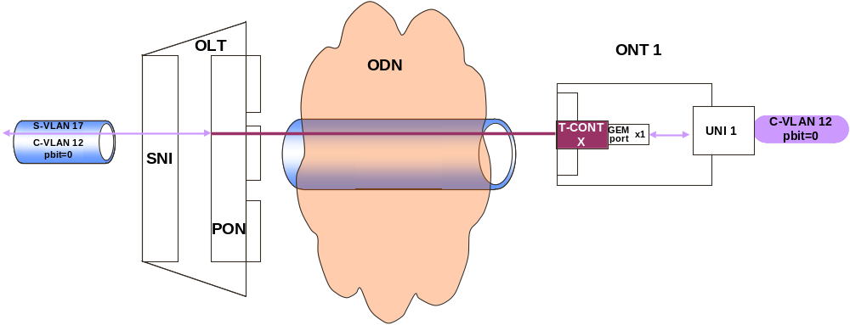
Figure 9: single VID with single pbit (dual tagged, single UNI)
Test Case n°5.2

Test Setup: Shown in Figure 9.

Purpose:
This test verifies the GPON system capability to deliver a VLAN architecture based on the following description:
- 2 VLAN levels on the aggregation network side and 1 VLAN level on the access network side
- Each flow on the customer network side is 802.1q tagged
- Replication of the C_VID value
- Replication of the pbit value
- Unique S_VID per PON port
- 1 C_VID value per GEM port
- 1 pbit value per GEM port
- 1 GEM port per TCONT
At the ONT only one UNI interface is used

Standard: Section 5.1.2 of TR-156 and ITU-T G984.4 Implementers' Guide

Preconditions:
All provisioning and management process between OLT and ONT must be fully compliant with ITU-T G984.4 OMCI Implementers' Guide version 1

Test Equipment: Ethernet tester

Test Procedure
Simultaneous transmission with all VLAN (12)
Use OMCI commands to setup the entire configuration from the OLT to the ONT described in Figure 9
- Create a connection between the OLT and ONT with a C_VID identifier (VID=xx) and C_p_bit identifier (p_bit=n) and a S_VID+C_VID identifier (S_VID=yy and C_VID=xx) and S_p_bit identifier (p_bit=n).

Step 1: Define and send following frames (upstream direction)
 | Dst Mac Address | Scr Mac Address | C-VID | C_p_bit | Data
Frame 1 | 00-00-00-00-11 | 00-00-00-00-01 | 12 | 0 | XXXXXX
Verify that frames below are received on SNI port with the S-VID ≠ C-VID, and S_p_bit = C_p_bit.
 | Dst Mac Address | Scr Mac Address | S-VID  +C-VID | S_p_bit | Data
Frame 1 | 00-00-00-00-11 | 00-00-00-00-01 | 17 + 12 | 0 | XXXXXX

Step 2: Define and send following frames (downstream direction)
 | Dst Mac Address | Scr Mac Address | S-VID  +C_VIS | S_p_bit | Data
Frame 1 | 00-00-00-00-01 | 00-00-00-00-11 | 17 + 12 | 0 | XXXXXX
Verify that frames below are received on UNI port with the C-VID ≠ S-VID, and C_p_bit ≠ S_p_bit.
 | Dst Mac Address | Scr Mac Address | C-VID | C_p_bit | Data
Frame 1 | 00-00-00-00-01 | 00-00-00-00-11 | 12 | 0 | XXXXXX

Verify if these flows use the correct GEM ports / TCONTs

Pass-fail criteria:
Pass if flows correctly forwarded on the GPON system. Correctly means "as described in section "Test Procedure""

Test report: Pass _____ Fail _____ Not Supported _____

Observation:
Last Modified:

VLAN architecture: VBES mode

Architecture n°1: VBES architecture with p_bit mapping (pbit only)
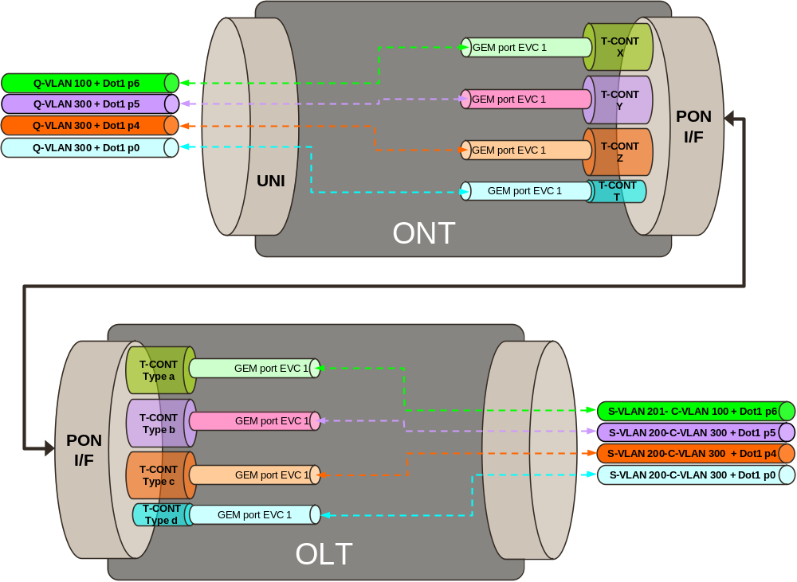
Figure 10: VBES architecture (dual tagged)

Test Case n°6

Test Setup: Shown in Figure 10

Purpose:
This test verifies the GPON system capability to deliver a VLAN architecture based on the following description:
- 2 VLAN level on the aggregation network side and on the access network side
- Flow on the business network side can be 802.1q tagged, untagged or priority tagged
- Replication of the C-VID value
- Replication of the pbit value
- S-VID is added at the ONU (one S-VID value per C-VID value)
- 1 pbit value per GEM port
- 1 GEM port per TCONT
- Each TCONT is associated to one specific p_bit value
At the ONT only one UNI interface is used

Standard: Section 5.1.3 of TR-156 and ITU-T G984.4 Implementers' Guide

Preconditions:
All provisioning and management process between OLT and ONT must be fully compliant with ITU-T G984.4 OMCI Implementers' Guide version 1.

Test Equipment: Ethernet tester

Test Procedure
For simultaneous transmission with all p_bit (6, 5, 4, 0)
Use OMCI commands to setup the entire configuration from the OLT to the ONT described in Figure 10
- Create a connection between the OLT and ONT with a C_VID identifier (C_VID=xx) and C_p_bit identifier (p_bit=n) and a S_VID+C_VID identifier (S_VID=yy and C_VID=xx) and S_p_bit identifier (p_bit=n).

Step 1: Define and send following frames (upstream direction)
 | Dst Mac Address | Scr Mac Address | C-VID | C_p_bit | Data
Frame 1 | 00-00-00-00-11 | 00-00-00-00-01 | 100 | 6 | XXXXXX
Frame 2 | 00-00-00-00-12 | 00-00-00-00-02 | 300 | 5 | XXXXXX
Frame 3 | 00-00-00-00-13 | 00-00-00-00-03 | 300 | 4 | XXXXXX
Frame 4 | 00-00-00-00-14 | 00-00-00-00-04 | 300 | 0 | XXXXXX
Verify that frames below are received on SNI port with the S_VID+C-VID, and S_p_bit = C_p_bit.
 | Dst Mac Address | Scr Mac Address | S-VID+C-VID | S_p_bit | Data
Frame 1 | 00-00-00-00-11 | 00-00-00-00-01 | 201+100 | 6 | XXXXXX
Frame 2 | 00-00-00-00-12 | 00-00-00-00-02 | 200+300 | 5 | XXXXXX
Frame 3 | 00-00-00-00-13 | 00-00-00-00-03 | 200+300 | 4 | XXXXXX
Frame 4 | 00-00-00-00-14 | 00-00-00-00-04 | 200+300 | 0 | XXXXXX

Step 2: Define and send following frames (downstream direction)
 | Dst Mac Address | Scr Mac Address | S-VID+C-VID | S_p_bit | Data
Frame 1 | 00-00-00-00-01 | 00-00-00-00-11 | 201+100 | 6 | XXXXXX
Frame 2 | 00-00-00-00-02 | 00-00-00-00-12 | 200+300 | 5 | XXXXXX
Frame 3 | 00-00-00-00-03 | 00-00-00-00-13 | 200+300 | 4 | XXXXXX
Frame 4 | 00-00-00-00-04 | 00-00-00-00-14 | 200+300 | 0 | XXXXXX
Verify that frames below are received on UNI port with the C-VID, and C_p_bit = S_p_bit.
 | Dst Mac Address | Scr Mac Address | C-VID | C_p_bit | Data
Frame 1 | 00-00-00-00-01 | 00-00-00-00-11 | 100 | 6 | XXXXXX
Frame 2 | 00-00-00-00-02 | 00-00-00-00-12 | 300 | 5 | XXXXXX
Frame 3 | 00-00-00-00-03 | 00-00-00-00-13 | 300 | 4 | XXXXXX
Frame 4 | 00-00-00-00-04 | 00-00-00-00-14 | 300 | 0 | XXXXXX

Verify if these flows use the correct GEM ports / TCONTs

Pass-fail criteria:
Pass if flows correctly forwarded on the GPON system. Correctly means "as described in section "Test Procedure""

Test report: Pass _____ Fail _____ Not Supported _____

Observation:

Last Modified:

Blindfold pairing

The purpose of blindfold pairing is to verify that an OLT is able to configure service architecture for different ONTs vendors with unique sequence of CLI commands or a batch mode file given by the OLT vendors.

During one of each official pairings session:
- An OLT vendor will be chosen
  - This OLT vendor won't be part of the official session
  - Other OLT vendors will be part of a "normal" test session, they will test scenarios described in this test plan
- ONT vendors which be part of blindfold pairings are ONTs who are not involved in a current "normal" test session (Idle ONT vendors)
- A single service architecture will be tested
- The architecture chosen is the architecture n°2 from the N:1 section (section 4.2.2).
- All OLT vendors have to provide a unique OLT configuration procedure (Sequence of necessary CLI commands or a batch mode file) to the organizer
  - To add a new ONT
    - This sequence must include all steps of the configuration process including the provisioning process using the serial number method
  - To delete an ONT
    - This sequence must include all steps to erase an ONT configuration including the serial number
- During the pairing:
  - The lab manager will play this configuration sequence by himself (without any vendors team intervention)
  - The OLT under test will be tested in front of different ONTs

OMCI traces will be asked to vendors who are involved in each blindfold pairings.

One GPON analyzer provider will be invited to join each blindfold pairing.

Provisioning using Registration ID method

Test Case n°7

Test Setup: Shown in Figure 2

Purpose: To verify that the OLT can initialize the ONU using the registration ID method

Standard:
Section 10 of G.984.3
Section 7.2 TR-156

Preconditions:
1. Registration ID is configured at the ONU
2. ONU not connected to the PON and powered down. At the OLT, the registration ID of the ONU is configured.

Test Equipment: None

Test Procedure:
1. Connect the ONU to the fiber and Power Up it
2. Before being provisioned with the Reg ID, check that the ONU cannot synchronize to the OLT
3. The method must be equivalent as described in TR156 section 7.2
4. The ONU shall range

Pass-fail criteria: Fail if the ONU does not range

Test report: Pass _____ Fail _____ Not Supported _____

Observation: Please find below a clarification on messages exchanges

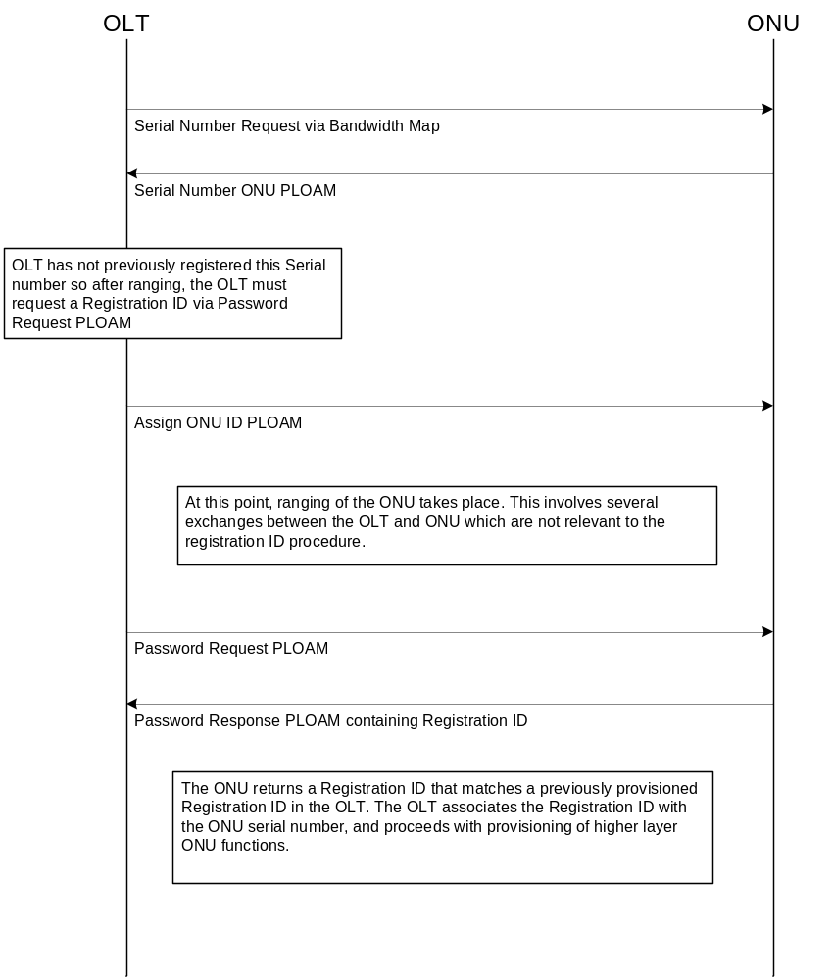

If the ONU responds with a serial number that is not already known by the OLT, then the OLT will, if registration IDs have been provisioned, send a Password Request PLOAM to the ONU. The ONU will respond with a Password Response PLOAM containing the Registration ID that was entered by the ONU installer.
The registration ID is an identifier that avoids the need for a-priori knowledge of physical devices. This registration ID will be communicated by the ONU to the OLT through the use of the Password Response PLOAM after the completion of ranging. After an ONU has initially registered with an OLT, its serial number will be known by the OLT when any subsequent re-ranging occurs, and the OLT need not solicit the registration ID from that ONU again.

Last Modified:

Tests Schedule
The following provides a proposed weekly test schedule. There are a total of 9 test sessions throughout the event, with each test session having at most 5 parallel test pairings.

Monday | 08.00 -12:00 | Set up time for all participants
 | 12:00 – 13:00 | Lunch
 | 13:00 – 16:00 | Test Session #1 (up to 5 active pairings )
 | 16:00 – 19:00 | Test Session #2 (up to 5 active pairings )
 | 19:30 | Closing test room
Tuesday | 08:30 | Room opening
 | 09.00 - 12.00 | Test Session #3 (up to 5 active pairings )
 | 12:00 – 13:00 | Lunch
 | 13:00 – 16:00 | Test Session #4 (up to 5 active pairings )
 | 16:00 – 19:00 | Test Session #5 (up to 5 active pairings )
 | 19.30 | Closing test room
Wednesday | 08:30 | Room opening
 | 09.00 - 12.00 | Test Session #6 (up to 5 active pairings )
 | 12:00 – 13:00 | Lunch
 | 13:00 – 16:00 | Test Session #7 (up to 5 active pairings )
 | 16:00 – 19:00 | Test Session #8 (up to 5 active pairings )
 | 19.30 | Closing test room
Thursday | 8.00 | Room opening
 | 08.30 – 10.15 | Blindfold pairing (up to 3 active pairing)
 | 10.30 – 12.00 | Blindfold pairing (up to 3 active pairing)
 | 12.00 – 13.00 | Lunch
 | 13.15 – 14.45 | Blindfold pairing (up to 3 active pairing)
 | 15.00 – 16.30 | Blindfold pairing (up to 3 active pairing)
 | 16.45 – 18.15 | Blindfold pairing (up to 3 active pairing)
 | 18.45 | Closing test room
Friday | 7.45 | Room opening
 | 09.00 - 12.00 | Test Session #9 (up to 5 active pairings )
 | 12.00 - 16.00 | Equipment break-down and Lunch

Expected result metrics

20 minutes before the end of each pairing, OLT vendors and ONT vendors will have to fill a specific document using the ETSI web application.

If needed, this file could also be used:



Annexes

Annex 1: Template for test cases

Template for test cases

Test Case #

Test Setup

Purpose:
.

Standard:

Preconditions:
.

Test Equipment:
.

Test Procedure
1. .

Pass-fail criteria:
.

Test report: Pass _____ Fail _____ Not Supported _____

Observation:

Last Modified:

